Convocatoria de ayudas de Proyectos de Investigación Fundamental no orientada

TECHNICAL ANNEX FOR TYPE A or B PROJECTS

1. SUMMARY OF THE PROPOSAL (the summary must be also filled in Spanish)

PROJECT TITLE: Integrating Nanotechnology with Dynamic Chemistry for Fluorescence in-situ micro-RNA Analysis. High Specific and Sensitive Multiplex Platform

PRINCIPAL INVESTIGATOR: Juan J. Díaz Mochón

SUMMARY

(brief and precise, outlining only the most relevant topics and the proposed objectives)

The aim of the project is to develop novel reagents (fluorescently-labelled abasic peptide nucleic acid –PNA- probes and aldehyde-modified nucleobases) and protocols to perform fluorescence in-situ hybridization assays for the simultaneous detection of RNA. Of particular interest is the possibility of performing micro-RNA in-situ hybridization (ISH) assays which are very challenging for the current ISH technologies due to their short length (20-26nt). The proposal takes advantage of the very high specificity given by an already validated chemical-based technology for nucleic acid detection together with the high sensitivity offered by fluorescently labelled-nanoparticles. Biorthogonal groups will be attached to the aldehyde-modified nucleobases and will act as handle for nanoparticles modified by specific partners of each bio-orthogonal tag. In this way, fluorescence nanoparticles will be the signal “amplifiers”providing the required sensitivity to the process. This proposal will tackle the intrinsic issue of many of the current ISH technologies which relates to false positives created by signals coming from unbound-probes, labels and/or mismatched hybridizations.

To avoid false-positives two different approaches will be investigated (i) signal co-localization and (ii) FRET. The chemical-based approach specifically allows the single dynamic incorporation of an aldehyde-modified tagged-nucleobases on the abasic PNA when the target RNA strand templates the reaction. Therefore, only when both entities, labelled-PNA probes and nucleobases, will be in close proximity a positive signal through either co-localization or FRET will be generated. This unique and innovative chemical-based technology will avoid false-positives and therefore will become a very exciting prospect as a clinical diagnostic tool.

TÍTULO DEL PROYECTO: Integración de Nanotecnología con Química Dinámica para el Análisis Fluorescente In Situ de microRNA. Plataforma Multiplex de Alta Especificidad y Sensibilidad

RESUMEN

(breve y preciso, exponiendo solo los aspectos más relevantes y los objetivos propuestos)

El objetivo de este proyecto es el desarrollo de nuevos reactivos y protocolos para realizar ensayos de hibridación fluorescente in situ para la detección simultánea de RNA, mRNA y micro-RNA. Es especialmente interesante la posibilidad de realizar ensayos de fluorescencia in situ de micro-RNA debido a que son muy difíciles de detectar con las tecnologías actuales debido a la corta longitud de dichos oligonucleótidos (20-26nt).

Esta propuesta presenta ventajas únicas que provienen de dos factores, la alta especificidad de la tecnología de análisis de ácidos nucleicos basada en química dinámica conjuntamente con la alta sensibilidad que ofrecen las nanopartículas fluorescentes. Para conseguir que ambas tecnologías puedan funcionar conjuntamente, las nucleobases funcionalizadas con aldehidos que se usan en la química dinámica se modificarán con grupos biortogonales para que éstos puedan ser reconocidos de forma muy específica por sus correspondientes partner reactivos, que se encontrarán en la superficie de las nanopartículas. De este modo las nanopartículas fluorescentes actúan como amplificadores de señales. Esta propuesta aborda uno de los problemas intrínsecos de muchas de las tecnologías actuales, la presencia de falsos positivos creados por señales procedentes de sondas no hibridizadas, etiquetas sueltas y/o mis-hibridaciones.

Para evitar los falsos positivos se van a llevar a cabo dos estrategias diferentes: (i) señales colocalizadas, y (ii) FRET. La estrategia basada en el reconocimiento de ácidos nucleicos por medio de química dinámica permite la incorporación selectiva de las nucleobases-aldehído a los oligómeros abásicos de PNA marcados con marcadores fluorescentes, sólo cuando la hebra de RNA complementaria está presente y por tanto moldea la reacción de incorporación. Por lo tanto, sólo cuando ambas entidades, las sondas de PNA y la nucleobase incorporada estén muy próximas una señal positiva se generará mediante colocalización o FRET. Esta tecnología basada en hibridazión y química dinámica será única e innovadora ya que evitará los falsos positivos y, por lo tanto, se convertirá en una herramienta muy interesante en el campo del diagnóstico clínico.

2. INTRODUCTION

(maximum 5 pages)

The introduction should include: the aims of the project; the background and the state of the art of the scientific knowledge, including the essential references; the most relevant national and international groups working in the same or related topics

2.1 Fluorescence in situ hybridization (FISH)

Fluorescence in situ hybridization (FISH) has been used for more than two decades since early 1980.¹ Those probes have been mainly used to detect, and localize the presence or absence of specific DNA sequences on chromosomes by fluorescence microscopy.² FISH uses fluorescent probes that bind to only those parts of the chromosome with which they show a high degree of sequence complementarity. FISH is often used for finding specific features in DNA and it is use by health services to give genetic counselling³ and as a tool of molecular diagnosis (Fig.1).^{4,5}

FISH probes have also been developed to detect RNAs within tissue samples. While whole gene expression profiles ‘paint a picture’ of a tissue as if it were homogeneous, for cases as tumoral tissues where heterogeneity is a prevalent feature FISH technologies help to define the spatial-temporal patterns of gene expression within cells and tissues.⁶ The principle of any FISH RNA assays is based on the use of probes with high specificity towards the target strand which provide enough sensitivity meaning high signal strengths from attaching the target RNA with so many fluorescent dye molecules that each RNA molecule becomes visible as a diffraction-limited fluorescent spot. It is assumed that generally 30–50 labels are needed to detect individual molecules of mRNA.⁶ Three different approaches have been developed (i) to use a large number of fluorescently-labelled oligonucleotides which target the same RNA target ^{7,} ⁸, (Fig. 2) (ii) to use less number of probes but heavily labelled⁹ and (iii) to use a sandwich approach to amplify the signal through multiple hybridizations (Fig. 3).¹⁰
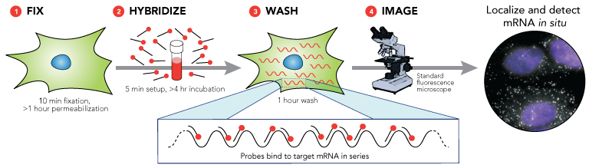
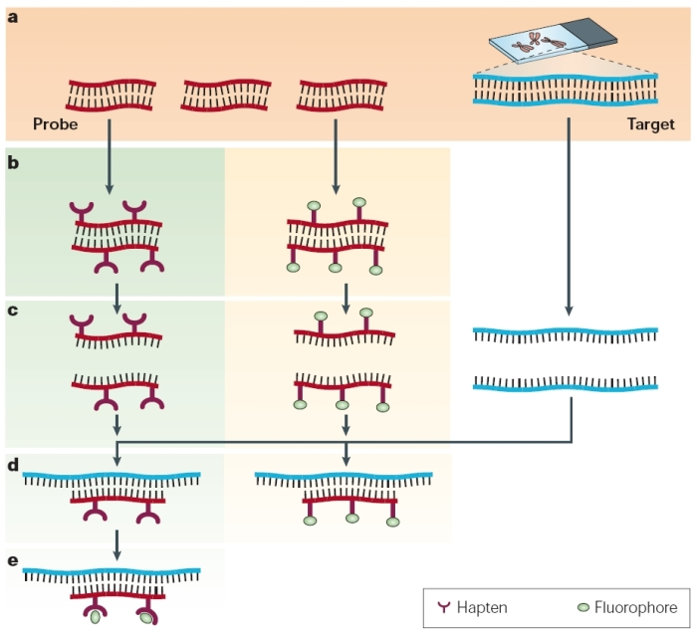

Fig. 2. FISH approach which uses a large number of fluorescently-labelled oligonucleotides which target the same mRNA.⁷

Fig. 1. FISH probes to detect a target DNA section.⁴

While the sensitivity issue has been achieved as mentioned above the specificity is tackle through bio- informatics design of the multiple probes and the use of nucleic acid mimics such as Peptide Nucleic Acid (PNA)¹⁰ and Locked Nucleic Acid (LNA).¹¹

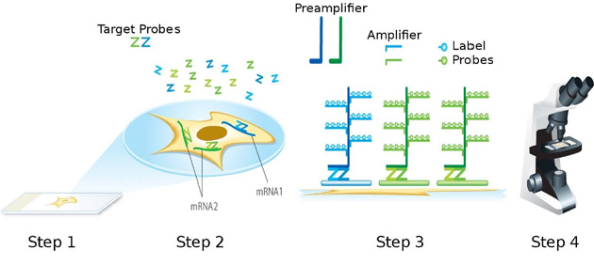

Fig. 3. FISH approach which use a sandwhich approach to amplify the signal through multiple hybridizations.¹⁰

2.2. micro-RNA

In the past decade miRNAs have emerged as regulators of gene expression that act as markers of tissues and pathological conditions.^{13a} Despite rapid advances in our understanding of miRNA biogenesis and mechanism,¹³ many fundamental questions still remain regarding miRNA function and their influence on cell cycle control. Their role have started to be decoded and have been presented as “braker”/”accelerator” of cell biology through regulation of mRNA translation.¹⁴ Therefore they have been postulated as key players in diseases such as cancer.¹⁵ They have been identified in tissues by rtPCR and can discriminate normal from tumour tissue. Considering recent reports and the heterogeneity found within cancer tissues it is likely that looking at the average miRNA expression of cell populations could result in the loss of important information connecting miRNA expression and cell function. Therefore in situ miRNAs detection in biopsy material would add a new avenue of evidence for diagnosis and prognosis. The main challenge in FISH applications is the optimization of sensitivity and specificity during probe design. This is even more acute when miRNA have to be detected due to their short length. Currently, there are no many efficient techniques to quantify miRNA expression at the single-cell level.

There are a few reports which present ISH technologies for miRNA analysis.¹⁶ These reports used tagged-LNA which allowed enzyme-based signal amplification.^{16,17} By tagging their probes with bio-orthogonal tags such as fluorescein, biotin or digogexin, which are not normally found within cells, “ELISA” type assays were able to be performed in fixed tissues, providing fluorescence signals where miRNAs were found. The big issue of these approaches is that they rely on a single hybridizaton step without being able to differentiate between signals coming from hybridised and non-hybridised probes, meaning that it will be difficult to avoid false-positive results.

2.3. Bio-orthogonal tags (BOT)

More and more often biomolecules, which can be either exogenous or created by the cell's own biosynthetic machinery through genetic engineering, are used to monitor and track different molecular biology processes. Therefore, there was a great need to tag these entities with groups which are non-native chemical handles that can be recognised through highly selective reactions by exogenously delivered probes. The chemical biology field provided an answer to that need via the bio-orthogonal chemical tags (BOT).¹⁸ Generally speaking, the bioorthogonal chemical reporter strategy involves the incorporation of unique functionality into targets of interest, followed by chemical labelling with a small-molecule probe. Bertozzi described this concept as follow “the selective reaction of compounds A and B bearing bioorthogonal functional groups proceeds in the presence of all the functionality found within living systems”.¹⁹ A recent application which offers the amplification of biomarker signals using the bio-orthogonal concept has been presented by Weissleder.²⁰ They modified antibodies with a bio-orthogonal chemical tag - trans-cyclooctene- which were then labelled by magneto-fluorescent nanoparticles coated with tetrazine through a metal-free chemoselective cycloaddition in living cells. They showed that the technique, named BOND (bio-orthogonal nanoparticle detection), was fast, chemoselective and adaptable to metal nanomaterials and capable to profile cancer cells using diagnostic magnetic resonance. This is a great example of how by integrating different chemical biology tools it is possible to create new technologies which can be applied for diagnosis purposes.

2.4 Nanoparticles

Nanoparticles-based assays offer a powerful approach for any aspects of drug discovery, encoding and diagnostic in medicine.²⁹ Fluorescent particles are used for a diverse number of biochemical assays including intracellular imaging, cellular tracking, as well as detection of a variety of biomolecules. Many strategies can be carried out for labeling of nanoparticles such as incorporation of the fluorescent dyes during polymerization process (that has the potential to generate highly fluorescent particles without reduction in the levels of functional groups available for conjugation of a desired cargo (drug, ligand, protein, etc) or employment of fluorescent monomers (that has the advantage of generating a homogeneous fluorescence distribution and long term fluorescence stability).³⁰ These which have been used include rhodamine and fluorescein that have been conjugated to an acrylic acid unit³¹ or nitrooxabenzodiazole linked to a methylmethacrylate and vinyl-derviatized naphthalimide.³²

2.5. Non-enzymatic Nucleic Acid Analysis

Several non-enzymatic based methods, apart from the classic allele-specific oligonucleotide (ASO) technology which is used for doing in situ hybridization, for the detection of nucleic acid analysis have been reported. DNA mimics such as peptide nucleic acids (PNAs) ²¹ have been used in a number of ligation-based chemical approaches, most notably in the elegant work of Seitz.²² Nonenzymatic ligation has also been achieved in a DNA–DNA sense by Kool ²³ who ligated DNA strands containing a 3’-phosphorothioate with a 5’-iodothymidine, and Richert ²⁴ who reacted nucleotides possessing an activated phosphate with a DNA strand containing a free 3’- amino group. DNA-templated dynamic chemistry has attracted interest for the preparation of stimuli-responsive polymers and for gaining insight into the chemistry of primordial self-replicating systems. Most recently, Liu and Heemstra have reported PNA-templated base-filling reactions on PNA strands.²⁵ However it is just us who have reported a distinct enzyme-free, dynamic chemistry based method of producing allele specific products for genotyping (see Section 3.2 and 4.1 for chemical structures).^{26, 27, 28}

2.6 Aims of the project
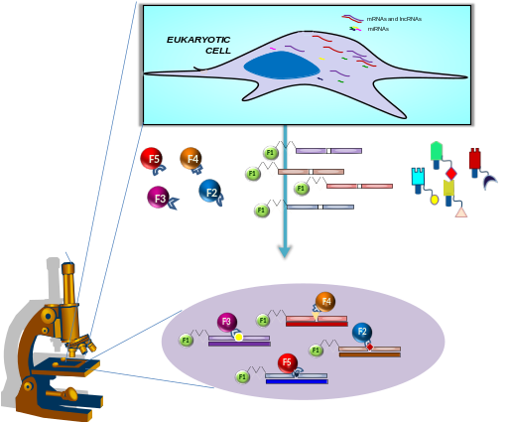

The main aim of the project is to develop novel set of chemical-based reagents and protocols to perform fluorescence in-situ hybridization for the detection of RNA species such as mRNA and specially miRNA, in tissues. The successful achievement of this proposal will mean the development of an unique multiplexing diagnostic platform for pathological labs. The proposed project takes advantage of the very high specificity of the already validated chemical-based technology for nucleic acid detection together with the high sensitivity given by high-performance labelled-nanoparticles (Fig. 4).

Fig. 4 Chem-ISH approach: Multiplexed chemical-based fluorescence in situ RNA analysis platform

To avoid false-positives two different approaches will be investigated (i) signal co-localization and (ii) FRET. The chemical-based approach specifically allows the single dynamic incorporation of an aldehyde-modified tagged-nucleobases on the abasic PNA when the target RNA strand templates the reaction. Therefore, only when both entities, labelled-PNA probes and nucleobases, will be in close proximity a positive signal through either co-localization or FRET will be generated. This unique and innovative chemical-based technology will avoid false-positives and therefore will become a very exciting prospect as a clinical diagnostic tool. At the moment there is a need in the clinical market for FISH probes for miRNA detection which together with probes to detect mRNA could create high specific pathological tests.

References

1.- Langersafer, P. R.; Levine, M.; Ward, D. C., Immunological Method For Mapping Genes On Drosophila Polytene Chromosomes. Proceedings of the National Academy of Sciences of the United States of America-Biological Sciences 1982, 79 (14), 4381-4385

2.- Ferguson-Smith, M. A.; Trifonov, V., Mammalian karyotype evolution. Nature Reviews Genetics 2007, 8 (12), 950-962.

3.- Nucaro, A.; Crisponi, G.; Minafra, L.; Rossino, R.; Cianchetti, C., A family with segregation of an unbalanced translocation (7;13)(q36;q32) in three patients with severe mental retardation, microcephaly and dysmorphic features, detected by subtelomere FISH: Genetic Counselling and prenatal diagnosis. Genetic Counseling, 2008, 19 (1), 37-42.

4.- O'Connor, C: Fluorescence in situ hybridization (FISH). Nature Education, 2008, 1, 1

5.- Awut, I.; Niyaz, M.; Xie, H.; Biekemitoufu, H.; Yan, Z. H.; Zhu, Z.; Sheyhedin, I.; Zhang, C.; Wei, Z.; Hao, W., Genetic diagnosis of patients with esophageal cancer using FISH. Oncology Letters 2010, 1 (5), 809-813.

6.- Pinaud, R.; Mello, C. V.; Velho, T. A.; Wynne, R. D.; Tremere, L. A., Detection of two mRNA species at single-cell resolution by double-fluorescence in situ hybridization. Nature Protocols 2008, 3 (8), 1370-1379.

7.- Orjalo, A.; Johansson, H. E.; Ruth, J. L., Stellaris fluorescence in situ hybridization (FISH) probes: a powerful tool for mRNA detection. Nature Meth 2011, 8 (10).

8.- (a) RNA Detection and Visualization: Methods and Protocols. RNA Detection and Visualization: Methods and Protocols 2011, 714;; (b) Raj, A.; van den Bogaard, P.; Rifkin, S. A.; van Oudenaarden, A.; Tyagi, S., Imaging individual mRNA molecules using multiple singly labeled probes. Nature Methods 2008, 5 (10), 877-879

9.- Femino, A.; Fay, F. S.; Fogarty, K.; Singer, R. H., Visualization of single RNA transcripts in situ. Science 1998, 280 (5363), 585-590.

10- Wang, F.; Flanagan, J.; Su, N.; Wang, L.-C.; Bui, S.; Nielson, A.; Wu, X.; Hong-Thuy, V.; Ma, X.-J.; Luo, Y., RNAscope A Novel in Situ RNA Analysis Platform for Formalin-Fixed, Paraffin-Embedded Tissues. Journal of Molecular Diagnostics 2012, 14 (1), 22-29.

11.- Larsen, R. D.; Schonau, A.; Thisted, M.; Petersen, K. H.; Lohse, J.; Christensen, B.; Philip, J.; Pluzek, K. J., Detection of gamma-globin mRNA in fetal nucleated red blood cells by PNA fluorescence in situ hybridization. Prenatal Diagnosis 2003, 23 (1), 52-59; Forrest, G. N.; Mankes, K.; Jabra-Rizk, M. A.; Weekes, E.; Johnson, J. K.; Lincalis, D. P.; Venezia, R. A., Peptide nucleic acid fluorescence in situ hybridization-based identification of Candida albicans and its impact on mortality and antifungal therapy costs. Journal of Clinical Microbiology 2006, 44 (9), 3381-3383.

12.- Robertson, K. L.; Thach, D. C., LNA flow-FISH: A flow cytometry-fluorescence in situ hybridization method to detect messenger RNA using locked nucleic acid probes. Analytical Biochemistry 2009, 390 (2), 109-114.

13.- (a) R Spizzo, M I Almeida, A Colombatti and G A Calin, Long non-coding RNAs and cancer: a new frontier of translational research? doi: 10.1038/onc.2011.621; (b) Poliseno, L.; Salmena, L.; Zhang, J.; Carver, B.; Haveman, W. J.; Pandolfi, P. P., A coding-independent function of gene and pseudogene mRNAs regulates tumour biology. Nature 2010, 465 (7301), 1033-U90.

14.- Lao, K.; Xu, N. L.; Sun, Y. A.; Livak, K. J.; Straus, N. A., Real time PCR profiling of 330 human micro-RNAs. Biotechnology Journal 2007, 2 (1), 33-35.

15.- (a) Cummins, J. M.; Velculescu, V. E., Implications of micro-RNA profiling for cancer diagnosis. Oncogene 2006, 25 (46), 6220-6227; (b) Li, B.; Shi, X.-B.; Nori, D.; Chao, C. K. S.; Chen, A. M.; Valicenti, R.; White, R. d. V., Down-Regulation of micro RNA 106b Is Involved in p21-Mediated Cell Cycle Arrest in Response to Radiation in Prostate Cancer Cells. Prostate 2011, 71 (6), 567-574

16.- (a) Sempere, L. F.; Preis, M.; Yezefski, T.; Ouyang, H.; Suriawinata, A. A.; Silahtaroglu, A.; Conejo-Garcia, J. R.; Kauppinen, S.; Wells, W.; Korc, M., Fluorescence-Based Codetection with Protein Markers Reveals Distinct Cellular Compartments for Altered MicroRNA Expression in Solid Tumors. Clinical Cancer Research 2010, 16 (16), 4246-4255; (b) Lu, J.; Tsourkas, A., Imaging individual microRNAs in single mammalian cells in situ. Nucleic Acids Research 2009, 37 (14).

17.- Baskin, D. G.; Breininger, J. F., Fluorescence in situ hybridization (FISH) of low abundance leptin receptor and SOCS-3 mRNA by tyramide signal amplification (TSA) and enzyme-linked fluorescence (ELF) methods. Journal of Histochemistry & Cytochemistry 2000, 48 (12), 1723-1723; Breininger, J. F.; Baskin, D. G., Fluorescence in situ hybridization of scarce leptin receptor mRNA using the Enzyme-Labeled Fluorescent substrate method and tyramide signal amplification. Journal of Histochemistry and Cytochemistry 2000, 48 (12), 1593-1599.

18.- Prescher, J. A.; Bertozzi, C. R., Chemistry in living systems. Nature Chemical Biology 2005, 1 (1), 13-21.

19.- Sletten, E. M.; Bertozzi, C. R., Bioorthogonal Chemistry: Fishing for Selectivity in a Sea of Functionality. Angewandte Chemie-International Edition 2009, 48 (38), 6974-6998.

20.- Haun, J. B.; Devaraj, N. K.; Hilderbrand, S. A.; Lee, H.; Weissleder, R., Bioorthogonal chemistry amplifies nanoparticle binding and enhances the sensitivity of cell detection. Nature Nanotechnology 2010, 5 (9), 660-665.

21.- Nielsen, P. E.; Egholm, M.; Berg, R. H.; Buchardt, O., Sequence-Selective Recognition Of Dna By Strand Displacement With A Thymine-Substituted Polyamide. Science 1991, 254 (5037), 1497-1500; Svensen, N.; Diaz-Mochon, J. J.; Bradley, M., Encoded peptide libraries and the discovery of new cell binding ligands. Chemical Communications 2011, 47 (27), 7638-7640; Pouchain, D.; Diaz-Mochon, J.; Bialy, L.; al., e., A 10,000 member PNA-encoded peptide library for profiling tyrosine kinases. ACS Chemical Biology 2007, 2 (12), 810-818; Diaz-Mochon, J.; Bialy, L.; Bradley, M., Dual colour, microarray-based, analysis of 10 000 protease substrates. Chemical Communications 2006, (38), 3984-3986.

22.- Grossmann, T. N.; Roeglin, L.; Seitz, O., Target-catalyzed transfer reactions for the amplified detection of RNA. Angewandte Chemie-International Edition 2008, 47 (37), 7119-7122.

23.- Xu, Y. Z.; Karalkar, N. B.; Kool, E. T., Nonenzymatic autoligation in direct three-color detection of RNA and DNA point mutations. Nature Biotechnology 2001, 19 (2), 148-152.

24.- riesang, N.; Giessler, K.; Lommel, T.; Richert, C., Four-color, enzyme-free interrogation of DNA sequences with chemically activated, 3 '-fluorophore-labeled nucleotides. Angewandte Chemie-International Edition 2006, 45 (37), 6144-6148.

25.- Heemstra, J. M.; Liu, D. R., Templated Synthesis of Peptide Nucleic Acids via Sequence-Selective Base-Filling Reactions. Journal of the American Chemical Society 2009, 131 (32), 11347.

26.- Bowler, F.; Diaz-Mochon, J.; Swift, M.; Bradley, M., DNA Analysis by Dynamic Chemistry. Angewandte Chemie-International Edition 2010, 49 (10), 1809-1812;

27.- Bowler, F. R.; Reid, P. A.; Boyd, A. C.; Diaz-Mochon, J. J.; Bradley, M., Dynamic chemistry for enzyme-free allele discrimination in genotyping by MALDI-TOF mass spectrometry. Analytical Methods 2011, 3 (7), 1656-1663.

28.- UK patent entitled “Nucleobase Characterisation” GB 0718255.3 filed on September 19, 2007 by Juan J. Diaz-Mochon and Mark Bradley (University of Edinburgh) and published on March 26, 2008 (WO/2009/037473).

29.- (a) Yingyongnarongkul, B.; How, S.; Diaz-Mochon, J.; al., e., Parallel and multiplexed bead-based assays and encoding strategies. Combinatorial Chemistry & High Throughput Screening 2003, 6 (7), 577-587; (b) Giljohann, D. A.; Seferos, D. S.; Daniel, W. L.; Massich, M. D.; Patel, P. C.; Mirkin, C. A., Gold Nanoparticles for Biology and Medicine. Angewandte Chemie-International Edition 2010, 49 (19), 3280-3294.

30.- (a) Thielbeer, F.; Chankeshwara, S. V.; Bradley, M., Polymerizable Fluorescein Derivatives: Synthesis of Fluorescent Particles and Their Cellular Uptake. Biomacromolecules 2011, 12 (12), 4386-4391; (b) Chavez, J. L.; Wong, J. L.; Jovanovic, A. V.; Sinner, E. K.; Duran, R. S., Encapsulation in sub-micron species: A short review and alternate strategy for dye encapsulation. IEE Proceedings Nanobiotechnology 2005, 152 (2), 73-84

31.- Sun, H.; Scharff-Poulsen, A. M.; Gu, H.; Almdal, K., Synthesis and characterization of ratiometric, pH sensing nanoparticles with covalently attached fluorescent dyes. Chemistry of Materials 2006, 18 (15), 3381-3384.

32.- Grabchev, I.; Petkov, C.; Bojinov, V., 1,8-naphthalimides as blue emitting fluorophores for polymer materials. Macromolecular Materials and Engineering 2002, 287 (12), 904-908.

33.- (a) Svensen, N.; Diaz-Mochon, J.; Bradley, M., Microwave-assisted orthogonal synthesis of PNA-peptide conjugates. Tetrahedron Letters 2008, 49 (46), 6498-6500; (b) Diaz-Mochon, J.; Fara, M.; Sanchez-Martin, R.; al., e., Peptoid dendrimers-microwave-assisted solid-phase synthesis and transfection agent evaluation. Tetrahedron Letters 2008, 49 (5), 923-926; (c) Diaz-Mochon, J. J.; Bialy, L.; Watson, J.; Sanchez-Martin, R. M.; Bradley, M., Synthesis and cellular uptake of cell delivering PNA-peptide conjugates. Chemical Communications 2005, (26), 3316-3318

34.- Sanchez-Martin, R. M.; Muzerelle, M.; Chitkul, N.; How, S. E.; Mittoo, S.; Bradley, M., Bead-based cellular analysis, sorting and multiplexing. Chembiochem 2005, 6 (8), 1341-1345.

35.- Alexander, L. M.; Sanchez-Martin, R. M.; Bradley, M., Knocking (Anti)-Sense into Cells: The Microsphere Approach to Gene Silencing. Bioconjugate Chemistry 2009, 20 (3), 422-426; Bradley, M.; Alexander, L.; Duncan, K.; Chennaoui, M.; Jones, A. C.; Sanchez-Martin, R. M., pH sensing in living cells using fluorescent microspheres. Bioorganic & Medicinal Chemistry Letters 2008, 18 (1), 313-317; Cardenas-Maestre, J. M.; Panadero-Fajardo, S.; Perez-Lopez, A. M.; Sanchez-Martin, R. M., Sulfhydryl reactive microspheres for the efficient delivery of thiolated bioactive cargoes. Journal of Materials Chemistry 2011, 21 (34), 12735-12743; Sanchez-Martin, R. M.; Cuttle, M.; Mittoo, S.; Bradley, M., Microsphere-based real-time calcium sensing. Angewandte Chemie-International Edition 2006, 45 (33), 5472-5474; Sanchez-Martin, R. M.; Alexander, L.; Muzerelle, M.; Cardenas-Maestre, J. M.; Tsakiridis, A.; Brickman, J. M.; Bradley, M., Microsphere-Mediated Protein Delivery into Cells. Chembiochem 2009, 10 (9), 1453-1456; Yusop, R. M.; Unciti-Broceta, A.; Johansson, E. M. V.; Sanchez-Martin, R. M.; Bradley, M., Palladium-mediated intracellular chemistry. Nature Chemistry 2011, 3 (3), 239-243.

36.- (a) Tholouli, E.; Hoyland, J. A.; Di Vizio, D.; O'Connell, F.; MacDermott, S. A.; Twomey, D.; Levenson, R.; Yin, J. A. L.; Golub, T. R.; Loda, M.; Byers, R., Imaging of multiple mRNA targets using quantum dot based in situ hybridization and spectral deconvolution in clinical biopsies. Biochemical and Biophysical Research Communications 2006, 348 (2), 628-636. (b) Oliva, A. A.; Swann, J. W., Fluorescence in situ hybridization method for co-localization of mRNA and GFP. Biotechniques 2001, 31 (1), 74

37.- Rosenblum, B. B.; Lee, L. G.; Spurgeon, S. L.; Khan, S. H.; Menchen, S. M.; Heiner, C. R.; Chen, S. M., New dye-labeled terminators for improved DNA sequencing patterns. Nucleic Acids Research 1997, 25 (22), 4500-4504

3. OBJETIVES

(maximum 2 pages)

3.1 Describe the reasons to present this proposal and the initial hypothesis which support its objectives (maximum 20 lines)

Micro-RNAs are key regulators of translational of an organism being responsible of different pathologies such as cancer, i.e. miRNA-21 it is over-expressed in nearly all solid tumours. Therefore they comprise a new class of promising diagnostic and prognostic biomarkers.

New probes and protocols for microRNA analysis in tissues need to be developed to be used as clinical diagnostic tools. Current in-situ hybridization technologies use probes to multi-label, via selective hybridization, either DNA fragments or mRNA strands. However and due to the short lenght of micro-RNA these approaches based on hybridization are very challenging for analysing them as there is just one hybridization step which control the whole outcome of the assay thereby being very prone to give false-positives.

Herein, we present a chemical based approach which is partially based on hybridization technologies. Most importantly, it offers a key innovation by introducing a proof reading step through dynamic chemistry giving rise to a unique way to control false-positive not just for miRNA detection but for any other nucleic acid. This unique two step process for "reading“ short micro-RNA produce two fluorescence signals in close proximity ONLY when a target nucleic acid is present, removing problems associated to false positives.

While the specificity of the new technology is controlled by the already validated dynamic chemical approach the sensitivity will be achieved by using fluorescently-labelled nanoparticles. In order to interface both an elegant and precise chemical biology tool, bio-orthogonality, will be used. Bio-orthogonal tags (BOT) and their reactive counter partner will be add to both modified nucleobases and nano-particles respectively so the labelling process can occur efficiently.

3.2. Indicate the background and previous results of your group or the results of other groups that support the initial hypothesis

Recently, we reported the application of dynamic chemistry to DNA analysis, offering the prospect of nonenzymatic nucleic acid.^{26, 27} This was achieved by the synthesis of a PNA strand that contained an “abasic” position opposite the nucleobase under analysis in a complementary DNA template. A reversible reaction, between this PNA/DNA duplex (specifically the secondary amine of the “PNA blank”) and four aldehyde-modifed nucleobases (Scheme 1), means that the templating power of Watson–Crick base pairing and base stacking would be expected to drive the selection of the fully complementary iminium nucleobase. Subsequent reduction and MALDI-TOF mass spectrometry allowed rapid determination of base incorporation.

Scheme 1. Dynamic chemistry applied to Nucleic Acid analysis.²⁶

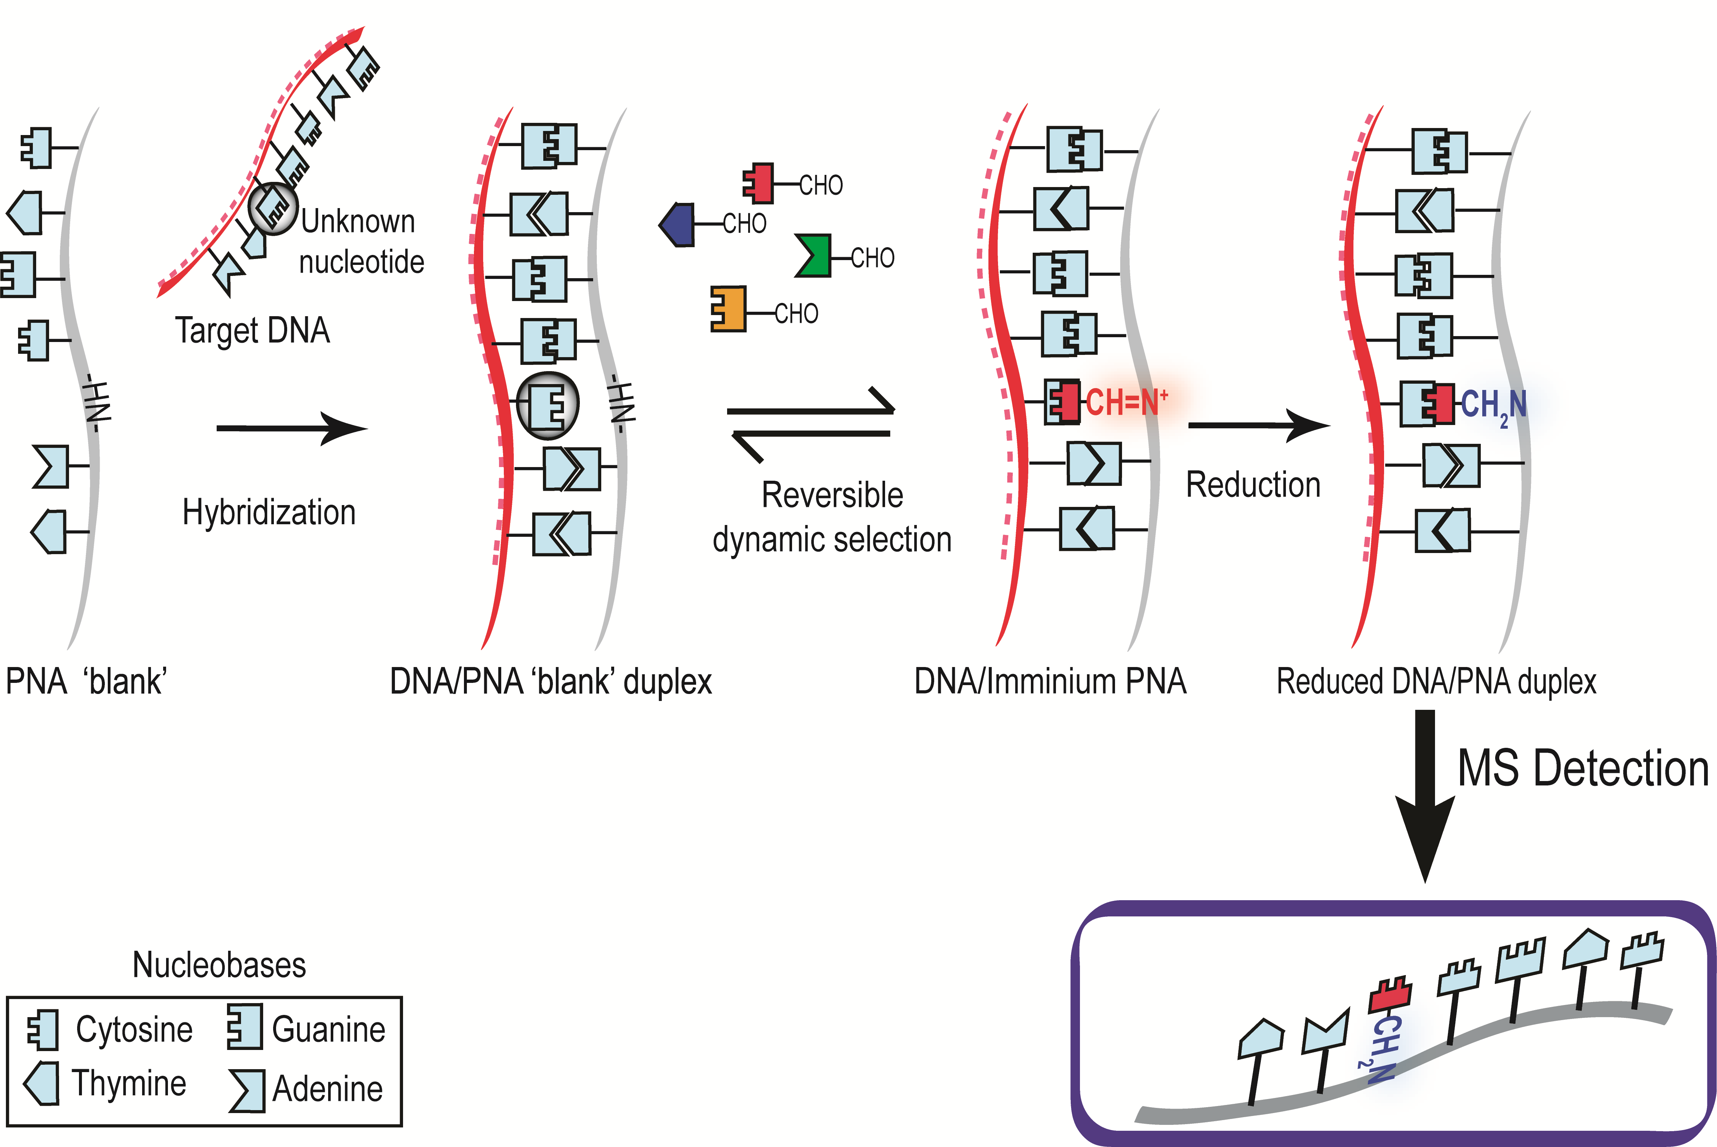
This approach was used to genotype cystic fibrosis patients. We developed a distinct enzyme-free dynamic chemistry-based method of producing allele-specific products for genotyping. ²⁷ In a blind trial, peptide nucleic acid (PNA) probes and aldehyde-modified nucleobases were employed to genotype twelve cystic fibrosis patients for two mutations (one SNP and one indel) linked to this disease. MALDITOF MS reported the resulting allele-specific products. Enzyme-free dynamic chemistry permitted the genotyping of twelve individuals for the ∆F508 (indel) and G551D (SNP) mutations (Fig. 5). No false positives or negatives were observed, and analysis could be performed in a multiplex format. The analysis stage was performed without enzymes, and there was no need for the stringent optimization and control of conditions associated with hybridization-based methods of allele-discrimination.

Fig. 5. Representative MALDI-TOF spectrum for duplex genotyping of G551D and ∆F508. The spectrum reports an individual heterozygous for both mutations, as peaks are observed for all four possible incorporation products I = Relative intensity (%)²⁷

This technology offers a very high specificity for the detection of nucleic due to two steps:

1) Selective hybridisation between abasic PNA-based highly affinity molecular probes and target nucleic acid.

2) Proof-reading step – selective dynamic incorporation of a specific aldehyde-modified nucleobase which eliminate false positives or high background due to mistmatches.

The dynamic chemical reaction can ONLY take place when the target nucleic acid forms a perfect duplex with a designed PNA probe. A signal is ONLY possible if the target nucleic acid is present. Consequently it avoids false-positives.

More recently, we have validated the technology using fluorescence as detection system. To do so, aldehyde-modified nucleobases were labelled with fluorescein and abasic PNA probes printind on microarray platform. The dynamic incorporation was firstly confirmed by MALDI-ToF and finally detected by fluorescence scanning (See Fig 6. – data not published)

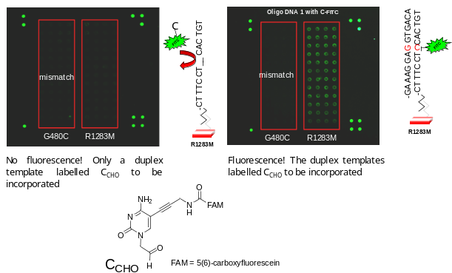
These results support the hypothesis that aldehyde-modified nucleobases tagged with bio-orthogonal groups (BOT) will be incorporated selectively onto the abasic PNA probe.

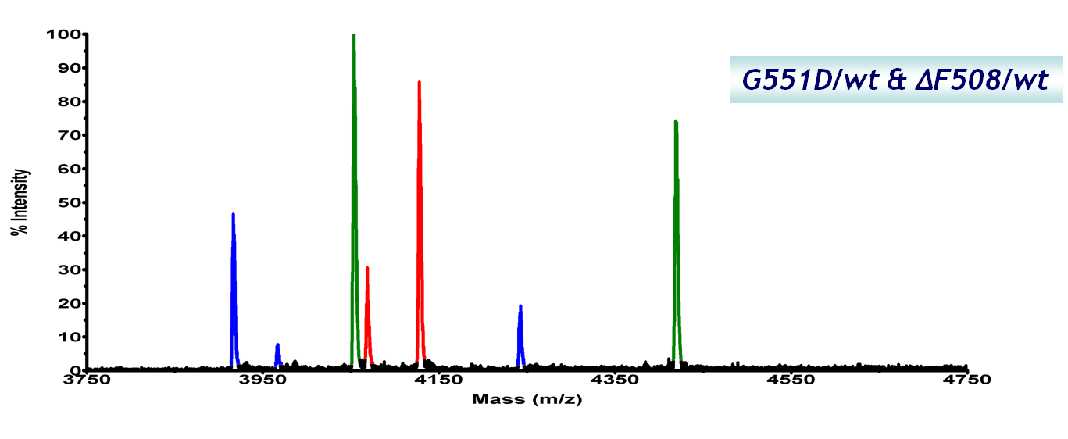
Fig 6. Allele discrimination of R1283M CF mutation using dynamic chemical approach with fluorescently labelled aldehyde-modified nucleobase on a microarray format. Fluorescence scanning was used. Data unpublished

3.3. Describe briefly the objectives of the project

1. Synthesis of modified aldehyde-modified nucleobases tagged with bio-orthogonal groups. BOT-Nucleobases

2. Synthesis of fluorescently-labelled abasic PNA probes targeting miRNAs.

3. Preparation of labelled-nanoparticles coated with reactive partners (small molecule, antibodies and or polymers) to recognised BOT-Nucleobases.

4. Evaluation of RNA-templated dynamic incorporation efficiency of the BOT aldehyde nucleobases onto abasic PNA probes by mass-spectroscopy MALDI-ToF and flow cytometry.

5. Investigation co-localizing and FRET approaches to develop multiplexing capability of the assay.

6. Development of protocols for FISH analysis in tissues using the Chem-ISH platform.

4. METHODOLOGY AND WORKING PLAN

(in the case of coordinated projects this title must include all the subprojects)

Detail and justify precisely the methodology and the working plan. Describe the working chronogram.

The working plan should contain the tasks, milestones and deliverables. The projects carried out in oceanographic ships or in the Antarctic zone must include the operation plan.

For each task, it must be indicated the centre and the researchers involved in it.

If personnel costs are requested, the tasks to be developed by the personnel to be hired must be detailed and justified. Remember that personnel costs are eligible only when personnel is contracted, fellowships are not eligible as personnel costs.

4.1 Synthesis of modified aldehyde-modified nucleobases tagged with bio-orthogonal groups.

Previously aldehyde-modified nucleobases without being tagged and unlabelled- abasic PNA probes have been reported by us (Fig. 7). ^{26,} ²⁷

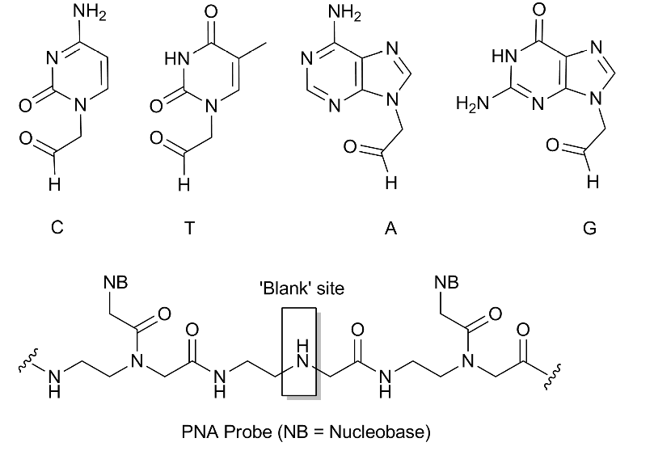

Fig. 7. Aldehyde-modified nucleobases and abasic PNA presented previously.²⁷

The novel BOT-nucleobases will be prepared as shown in scheme 2. We have experience in the preparation of these bases as mentioned in section 3.2 and do not envisage any significant problems with the synthesis. This scheme will be adopted to obtain bio-othogonal tagged materials. Briefly, after alkylation of the bromo and iodo-pyrimidine and purine derivatives, protected propargylamine will be introduced via classical Sonagashira coupling. Following deprotection of the exocyclic primary amine a coupling reaction will be carried out to introduce different bio-orthogonal tags (BOT). A final acetal deprotection step will give rise to the target aldehydes. A range of BOT will be explored to identify the best ones. Amongst them FLAG peptide, fluorescein, L-dopa, biotin and cyclo-octene will be investigated. As shown in section 3.2 aldehyde-modified cytosine has been already prepared containing a fluorescein group. That employed synthetic strategy (shown also in Scheme 2) will be applied.

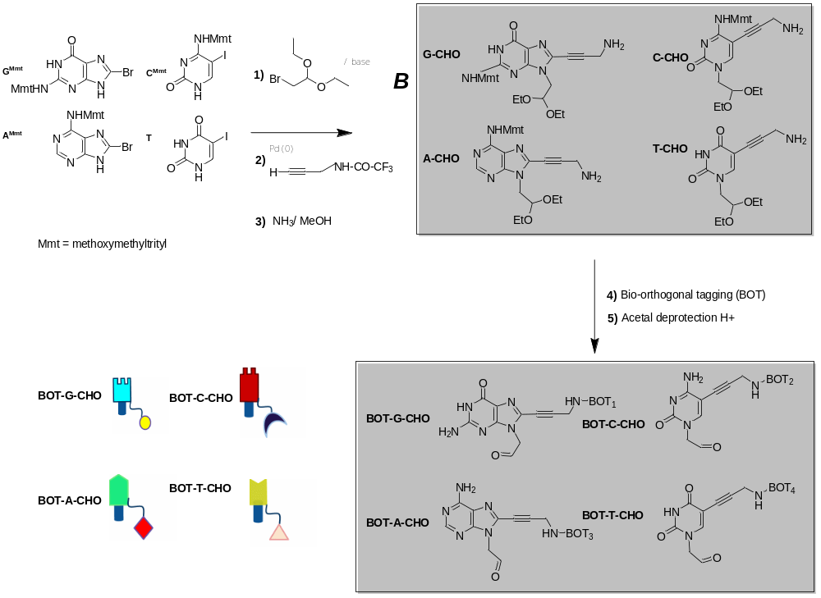

Scheme 2. Synthesis of BOT-aldehyde nucleobases

4.2. Synthesis of fluorescently-labelled abasic PNA probes targeting RNAs.

Abasic PNA synthesis will be performed using Fmoc-PNA monomers (these are commercially available from Link Technologies) plus a monomer needed to introduce the “abasic” site. The synthesis of the required monomer is shown in Scheme 3. Secondary amine of the commercially available Fmoc protected N-aminoethyl-glycine will be protected with Boc₂ (di-tert-butyl dicarbonate). We will use solid phase protocols assisted by microwave – protocols developed by the group- to speed up the probe preparation.³³ PNA probes will be designed to ‘clamp’ the region around 3’ UTR K-Ras area where mutations are known and also to “clamp” the different let-7 miRNA (in order to have a right design the PNA N-terminus have to line up with the 3’ end of the RNA strand). We have vast experience in the design and synthesis of these probes and protocols have been optimised to a very high level of efficiency. The synthetic route is depicted in Scheme 4.

Two different strategies will be tested to label the abasic PNA probes a) labelling with organic dyes and b) labelling with fluorescently-labelled nanoparticles. While to obtain the first type of probes standard procedures to couple organic dyes will be used for the second one a chemoseletive reaction will have to be performed as coupling of the probes onto the fluorescently-labelled nanoparticles will be carried out once the probes are cleaved from the PS resin. Therefore and before cleavage, abasic PNA probes will be modified with an acetylene group at their N-terminal end so that a Huisgen Cycloaddition (click chemistry) can be occur with azide-modified fluorescently labelled nanoparticles (other chemoselective reactions could be explored). Different labels such as fluorescein, rhodamine, Cy3 and Cy5 will be tested in both models.

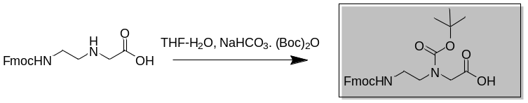

Scheme 3. Synthesis of monomer needed for introduce the abasic site.

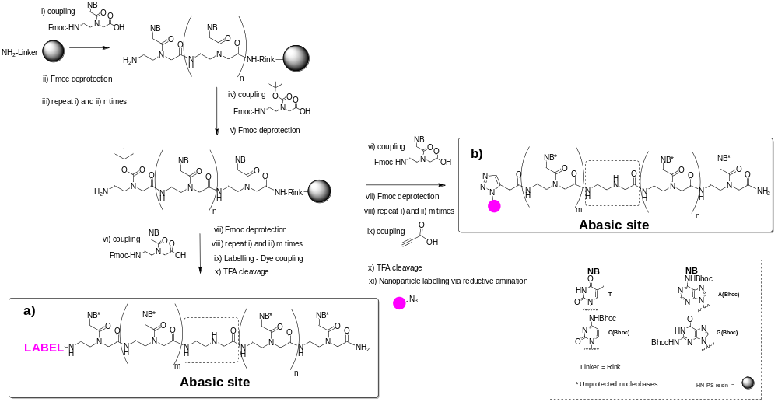

Scheme 4. Chemical strategy to synthesise fluorescently-labelled abasic PNA probes. NB = natural nucleobases (A, T, C and G); a) labelling with organic dyes and b) labelling with fluorescently-labelled nanoparticles

4.3.Preparation of labelled-nanoparticles coated with reactive partners (small molecule, antibodies and or polymers) to recognised bio-orthogonal tags (BOT)

Funtionalized and fluorescent-labelled nanopartciles will be synthesized by emulsion polymerization as previously described by our collaborator Sanchez-Martin³⁴ using functionalized and fluorescent-labelled styrene monomers following an modified protocol based on the one describe recently by our collaborator Bradley³⁰ and DVB as cross-linker. Then a range of reactive partners (small molecules, antibodies and or polymers) will be linked to the surface of the fluorescent nanoparticles following standard conjugation strategies which have been susesfully applied to couple from DNA, RNA, proteian to small molecules.³⁵ Then these nanoparticles will be ready to recognise bio-orthogonal tags (BOT). As a representative example, Scheme 5 shows the preparation of TAMRA-labelled nanoparticles (named as F3) and the conjugation via Schiff-base formation of streptavidin that will recognize specifically biotin as BOT. The same strategy will be applied with different dyes such as dichlororhodamines, Cy5-, texas-red and coumarine-monomers in the polymerization process will allow the preparation of F2, F4 and F5, respectively. Then each one of them will be linked to a specific reactive partner complementary to each of the BOT used to tag the nucleobases (see section 4.1). This chemical strategy will be carried out in collaboration with Dr. Sanchez-Martin from the University of Granada who is an expert in this nanotechnology. The preparation of nanoparticles of a range of size will allow the sorting of them by flow cytometry then we will be able to discriminate them by fluorescent emission and by size (Fig. 8).

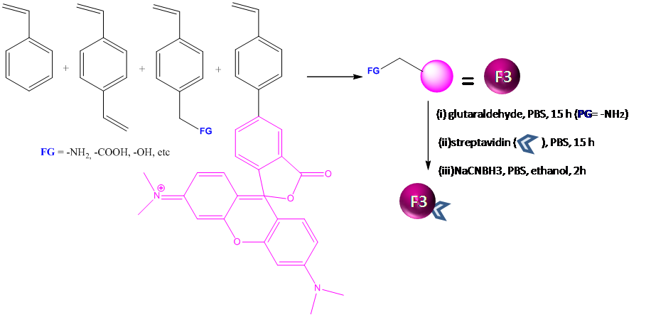

Scheme 5. representative example of the preparation of TAMRA-labelled nanoparticles.

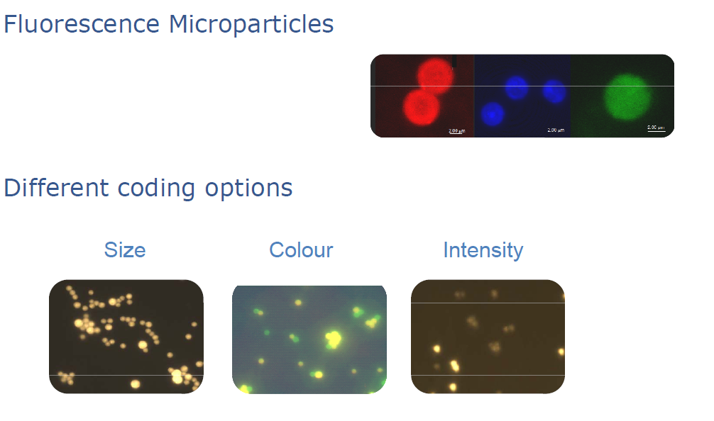

Fig. 8. Different strategy for nanoparticles detection.

4.4 RNA-templated dynamic incorporation efficiency of the BOT aldehyde nucleobases onto abasic PNA probes.

4.4.1. Determination by mass-spectroscopy MALDI-ToF^{26, 27}

The aim of this is to evaluate which of the new BOT-modified nucleobases have a better fitting into the chemical pocket. By using abasic probes type a described in Section 4.2 this can be investigated via MALDI-ToF as shown in Scheme 6.

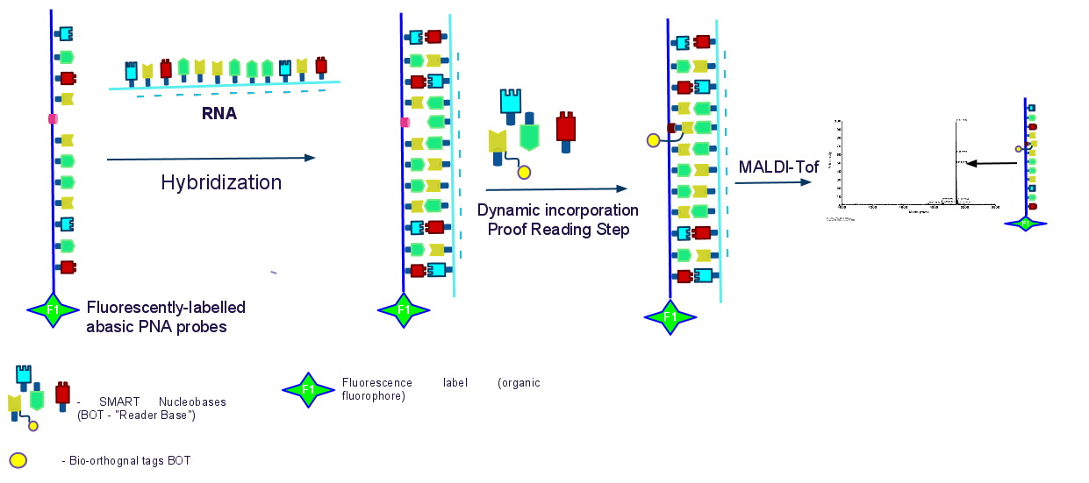

Scheme 6. MALDI-Tof analysis to investigate efficient RNA-templated dynamic incorporation of BOT-Nucleobases.

The group have preliminary unpublished data where an abasic PNA probe was labelled with TAMRA (5(6)-carboxy tetramethylaminorhodamine) was modified by an aldehyde-modifed cytosine labelled with fluorescein (Fig. 9) via a RNA-templated dynamic incorporation. A similar approach will be followed with the BOT-aldehyde nucleobases in order to assess which BOT is more efficient and if there are some of them which do not allow the dynamic incorporation process.

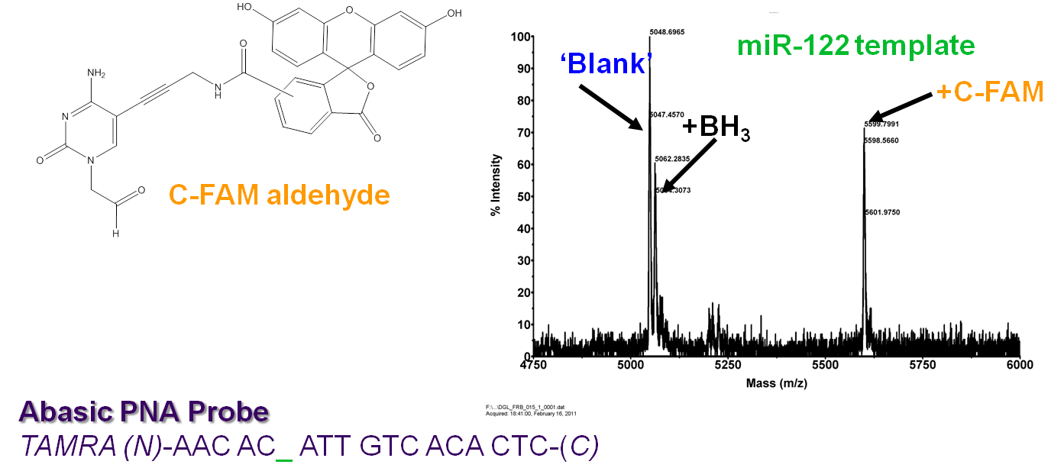

Fig. 9. MALDI-ToF of a succesful miRNA-templated FAM-cytosine incorporation on a fluorescently-labelled abasic PNA .

4.4.2. Determination by Flow cytometry

The success recognition of BOT-aldehyde nucleobases by fluorescently labelled nanoparticles modified with their corresponding reactive partner can not be determine by MALDI-ToF so a flow cytometry approach will be followed. Both set of probes a and b described in 4.2 will be used. The simultaneous quantification of the two fluorescent signals coming from the abasic PNA probes (F1) and the nanoparticle (F2) will allow the unmistakable identification of the incorporated base with high efficiently. This is possible due to the fact that only when the specific ligand attach to the fluorescent nanoparticle recognise the BOT-nucleobase (that has been incorporated into the PNA-RNA probes ) we will obtain a dotplot with a population where positive F1/positive F2 are colocalised (see flow cytometry dot plot in bottom panel – Scheme 7). The presence of false positive is not possible because when the target RNA does not template the dynamic incorporation of the BOT-nucleobases then we will never have a population with F1/F2 positives (see flow cytometry dot plot in top panel – Scheme 7). In the same way we will be able to identify co-localization of the different partners (F1/F3, F1/F4 and F1/F5)

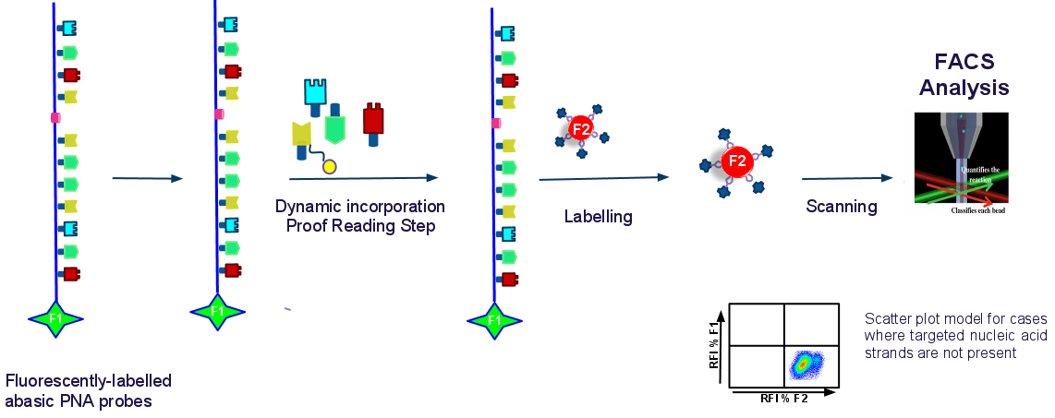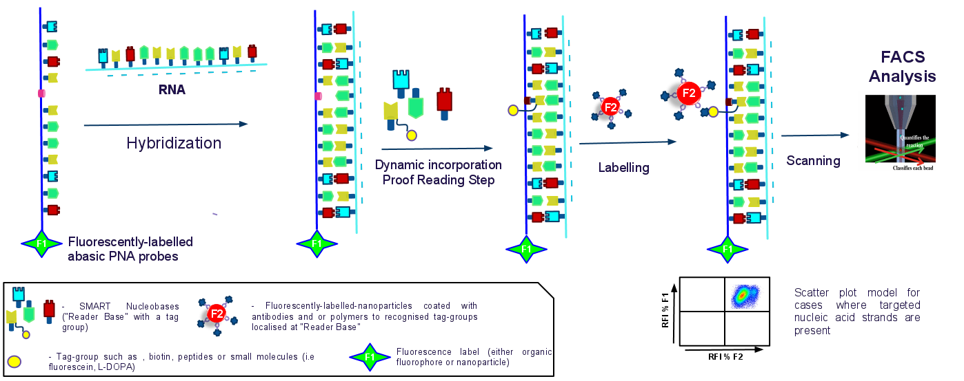

Scheme 7. Flow cytometry analysis

4.5 Investigate co-localizing and FRET approaches to develop multiplexing capability of the assay.

Scheme 8 represents how the technology will work to have multiplexing capabilities. Abasic PNA probes will be coded by a fluorophore. To do so optical coding approach based on the use of different fluorophores will be followed. Each RNA target will thus be identified by a different fluorescence signal which can detected in a single sample by high-performance fluorescence microscopy equipments. The University of Granada through their Central Services of the Centro de Instrumentación Científica offer to their staff microscopy facilities such as MICROSCOPIO CONFOCAL ESPECTRAL DE ALTA VELOCIDAD with four lasers and MICROSCOPIO DE FUORESCENCIA LEICA DM5500B which are able to detect up to 6 fluorophores per sample.

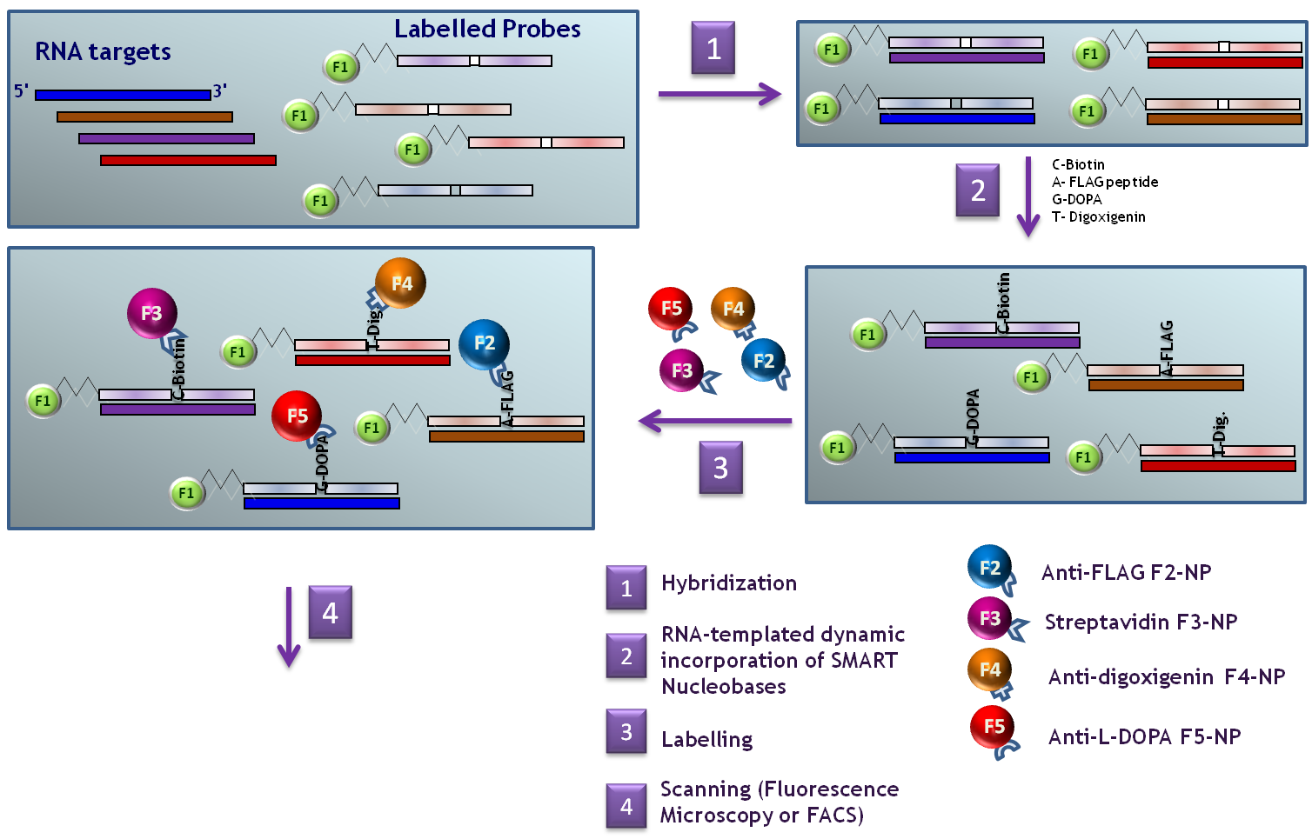

Scheme 8. Multiplex strategy for RNA detection by fluorescence microscopy using Chem-ISH reagents.

As shown in Scheme 8 to have a positive result, fluorescence signals coming from both the probes and nanoparticles linked to BOT nucleobases have to be in close proximity. Therefore either by co-localising or³⁶ FRET³⁷ based readings this technology could not provide false-positive results. As mentioned above the abasic PNA can only be modified by a nucleobase only if the target RNA strand is present. Therefore, only when the signal from the abasic probe and the signal coming from the BOT nucleobase via nanoparticle labelling are in close proximity it can be said that a given RNA strand is there.

Selected BOT nucleobases and their reactive partners coupled to fluorescently labelled nanoparticles following completion of objectives 1-4 will be used to carry out this part.

Scheme 9 shows a model of the co-localising approach. As fixed tissues will be used this approach can be used taking advantage of the fixed position of the target RNA and therefore standard software can easily deconvolute the digital data based on xy positions. The limit of RNAs which could be identified following this approach is limited by the fluorescence microsocope. Currently and using facilities found within the UGR up to 5 different colours can be detected per samples meaning that using these systems up to 4 RNA could be identified per sample (number of RNA detected = number of channels – n; n = number of labels per set of abasic PNA probes).

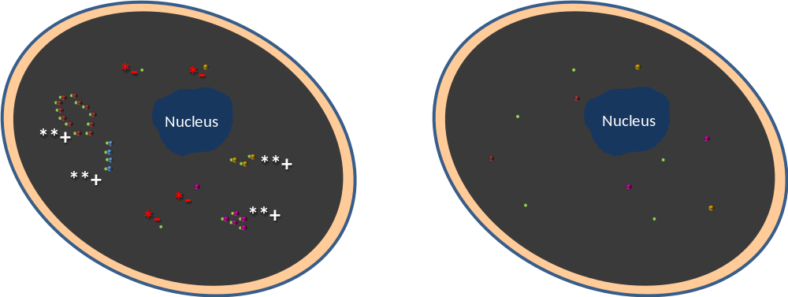

Scheme 9. Co-localising signal to avoid false positives. Left panel: when signals coming from probes and NP are co-localised then a positive results will be given (**+). If signals are not co-localised then it is due to background (*-). Right panel model containing non RNA targets.

Close proximity between labels of the abasic PNA probes and fluorophores of nanoparticles linked to the BOT incorporated nucleobase can be used to perform also FRET studies. The advantage of this system will be that theoretically the total signal is increased compared with direct dye excitation. Similar strategy than the one currently used in the highly successful Illumina DNA sequencer will be used (Scheme 10). We will use as F1, label of the abasic PNA probes, fluorescein which will act as donor, such as fluorescein, and dichlororhodamine dyes (F2-F5) as acceptors which will be the nanoparticles labelling. Fig 10 shows the spectral distribution of fluorescein-rhodamine dye sets.

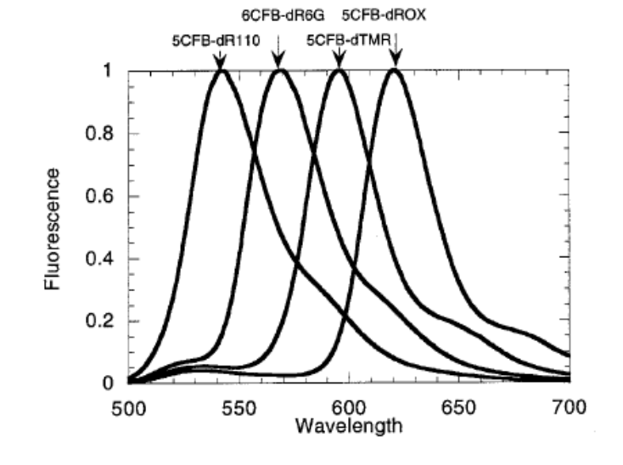

Fig 10. Spectral distribution of fluorescein-rhodamine dye sets when excited by fluorescein throguh FRET.³⁷

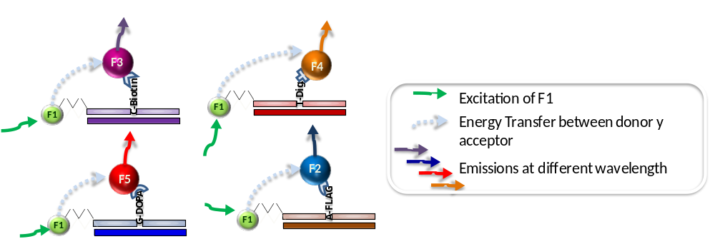

Scheme 10. FRET approach for Chem-ISH platform

Tagged-LNA oligomers will be used as control of the technology. Being at the moment the only probes which can detect miRNA it is essential to demonstrate that the new technology can outperform LNA.

4.6. Development of protocols for FISH analysis in tissues.

Protocols to perform fluorescence in situ miRNA analysis in tissues will be optimised. Initially tissues samples from commercial sources such as OriGene will be purchased and standard protocols adapted to the new technology. A key feature of the new protocol will be a quenching process to avoid side-reactions between the BOT-nucleobases, containing aldehyde groups, and cellular content. In the case of formalin-fixed tissues, that reactivity should not be an issue as para-formaldehyde is used to fixed the tissues so it would react with any biomolecules with amine groups.

Another key aim will be to determine which miRNAs are optimal (let7 family is a good and K-ras are good candidates as are over-expressed in cancer tissues). We will start with abundant miRNAs (which may show less specificity but are easier to detect) and follow this with less abundant miRNAs which show more tissue and disease stage specficity but are harder to detect.

4.7 Working Plan

The need for a post-doctoral researcher is clear by looking at the chronogram model. The field of chemical biology is relatively new in Spain and therefore there are not many consolidated permanent members who could participate as team members apart from the ones who are ineligible to participate due to their participation in other Ministry Funded Projects. In order to structure a successful team I thought it was a better investment to hire a high qualified researcher with the right skill set for this project rather than to build up a team with other staff members who do not have the appropriate background.

Nonetheless and in order to ensure the success I have secured the commitment of world-class researchers in key project areas such as fluorescence microscopy via the expertise of Dr. Cristina Flors (Royal Society Fellow and recently incorporated to the Instituto de Nanociencia IMdea de Madrid), flow citometry and nanotechnology with Dr. Rosario Sanchez Martin (former Royal Society Fellow and Profesora Titular de la Universidad de Granada – currently working in my own Department) and high-throughput chemical biology expertise through Prof. Mark Bradley (Fellow of the Royal Society of Edinburgh and Professor of High-throughput Chemical biology). Moreover I have also managed to get support from two biotechnological companies such as Gennova Scientific and DestiNA Genomics which will support the working plan in the areas of nanoparticle manufacturing and in situ hybridization protocol developments.

The working plan will be structured as follow:

1.- Synthesis of BOT-Nucleobases. The role of the PI and his experience is key to achieve this milestone. Dr. Diaz Mochon has already developed sets of modified nucleobases and in a period of 12 months up to 8 different BOT-nucleobases will be suitable to be prepared. A first of set of monomers will be synthesised in the first year. We foresee to spend some time towards the final third of the project as refined BOT-nucleobases will be needed. The hired researcher will support the PI in this task who will transfer his know-how to the new University member.

2. Synthesis of fluorescently-labelled abasic PNA probes targeting miRNAs. Solid-phase microwave assisted methods developed previously by the PI will be used to create these products. Parallel synthesis approaches will be followed which will allow to syntheses up to 8 different across the last four months of the first year of the proyect. The hired researcher will support the PI in this task as above.

3. Preparation of labelled-nanoparticles coated with reactive partners. This task will be the main task of the hired researcher who will have to have experience in the field of nanotechnology and will find the support of two experts such as Prof. Sanchez Martin and Prof. Bradley. Apart from this, Gennova Scientific will offer their production facilities regarding nanoparticles manufacturing. The PI will coordinate the efforts across the different collaborators and his own researcher.

4. RNA-templated dynamic incorporation efficiency of the BOT aldehyde nucleobases onto abasic PNA probes. This task will be pivotal for the success of the project. Finding the right BOT and reactive partners will define the success of the project. However, the PI feels very confident of make this findings based on his experience. He has already developed a whole biotechnological idea from bench to business based on this technology. Apart from this Dr. Sanchez Martin will support the flow citometry work. The hired researcher and PI will work together in this task, while the PI will lead the MALDI-ToF experiments the hired researcher will do the same with the flow cytometry one.

5. Investigate co-localizing and FRET approaches to develop multiplexing capability of the assay. This task will be performed in the last year of the project. The PI has large experience on fluorescence microscopy and FRET technology through his work with 10,000 members FRET-peptide libraries and also with his work related to cell-based microarrays. He will coordinate the efforts here to be assisted by the hired researcher. However it is a great privileged to have Dr. Flors as collaborator of the project. Dr. Flors is a leader in single-molecule fluorescence and will give priceless advices and support to this part of the project.

6. Development of protocols for FISH analysis in tissues. The last task of the project will be to start optimising protocols for chemical-based fluorescenc in-situ miRNA and mRNA analysis. DestiNA Genomics has the capability to offer support here.

4.1 CHRONOGRAM MODEL (EXAMPLE)

This chronogram must indicate the persons involved in the project, including those contracted with project funds.

Underline the name of the person responsible for each task.

Tasks | Centre | Persons | First Year (*) | Second Year (*) | Third Year (*)
4.1 Synthesis of modified aldehyde-modified nucleobases tagged with bio-orthogonal tags. | UGR | Juan J. Diaz-Mochon  Researcher | x|x|x|x|x|x|x|x|x| | | | | | | | | | | | | | | | |x|x| | | | | | | | |
4.2. Synthesis of fluorescently-labelled abasic PNA probes targeting miRNAs. | UGR | Juan J. Diaz-Mochon | | | | | | | |x|x|x|x| | | | | | | | | | | | | | |x|x| | | | | | | | |
4.3.Preparation of labelled-nanoparticles coated with reactive partners (small molecule, antibodies and or polymers) to recognised bio-orthogonal tags (BOT) | UGR | Juan J. Diaz-Mochon  Researcher | | | | | | | | | | | | | |x|x|x|x|x|x|x|x|x|x| | | | | | | | | | | | |
4.4 RNA-templated dynamic incorporation efficiency of the BOT aldehyde nucleobases onto abasic PNA probes | UGR | Juan J. Diaz-Mochon  Researcher | | | | | | | | | | | | | |x|x|x|x|x|x|x|x|x|x| | |x|x|x | | | | | | | |
4.5 Investigate co-localizing and FRET approaches to develop multiplexing capability of the assay. |  | Juan J. Diaz-Mochon  Researcher | | | | | | | | | | | | | | | | | | | | | | | | | | | |x|x|x|x|x|x|x|x|
4.6. Development of protocols for FISH analysis in tissues. |  | Juan J. Diaz-Mochon  Researcher | | | | | | | | | | | | | | | | | | | | | | | | | | | | | | | |x|x|x|x|
 |  |  | | | | | | | | | | | | | | | | | | | | | | | | | | | | | | | | | | | |

(*) Mark an X inside the corresponding boxes (months)

5. BENEFITS DERIVED FROM THE PROJECT, DIFFUSION AND EXPLOTATION OF RESULTS

(maximum 1 page)

The following items must be described:

Scientific and technical contributions expected from the project, potential application or transfer of the expected results in the short, medium or large term, benefits derived from the increase of knowledge and technology.

Diffusion plan and, if appropriate, exploitation plan of the results.

The project will deliver a completly new technology to detect RNA in tissue. The development of such an exciting and innovative technology may provide opportunities to engage with Spanish/multinational companies specialised in platforms/fluorescent detection methodologies as well as potentially providing new market opportunities to develop new platforms to support the exploitation of the technology. Currently two companies are actively interested in the project which secure the transfer process if the project is funded.

The opportunities in the medium and long term are:

• Large and financially attractive market that remains open to advances in technologies.

• Potential for considerable licensing deals. DestiNA Genomics Ltd. and Gennova Scientific have already showed their predisposition to do so.

• Potential to be useful as background IP to areas such as synthetic biology, chemical biology, biotechnology and nanotechnology

• To break in to market will need to show method is cost-efficient and superior (speed and accuracy will be our unique selling points) to well established methodologies.

In the short term the project will also deliver development and innovation in the different discipline involved in this project. For instance the chemical-based nucleic acid detection technology will benefit from the new findings and the new BOT-nucleobases created during the project could then be used for novel diagnostic tests, i.e. colorimetric assays to detect circulating microRNA which acts as biomarker. In the case of the nanotechnology field the development of new labelled nanoparticles capable to react selectively with BOT molecules will be used also in different applications, being of special interest their application in BOND assays. Finally, it is quite likely that this platform will be applied to flow cytometry assays for liquid cytology. All these paralell applications de-risk the project as a whole.

The research program will be efficient and effectively managed and research progress will be appropriately disseminated within the team and in the scientific community: it is the intention to contribute in high impact factor journals of Medicine, Chemistry, Biological Chemistry and Medicine such as Nature Biotechnology (29.495), ACS Chemical Biology (5.108), J. Biol. Chem. (impact factor 7.368), Angew. Chem. Int Ed. (8.547), J. Med. Chem. (4.134), J. Am. Chem. Soc. (6.025), y Org. Lett. (3.367). Previous to its publication the potential of the results to be patented will be studied by the office OTRI of the University of Granada. It is planned as well the annual participation in international congresses with strict evaluation such as the organized annually by prestigious organizations such as the American Chemical Society (ACS) and the Royal Society of Chemistry (RSC).

Dissemination of the new technology and their applications to the general public will also be performed using both mass and social media channels. Dr. Diaz-Mochon has experience in taking part in these PR activities.

6. BACKGROUND OF THE GROUP

(maximum 2 pages)

Later in 2010 I was awarded a researcher contract from the Subprograma Ramón y Cajal of the Spanish Ministry of Economy which I started in June 2011. Therefore this is my first proposal to be sent to the Spanish Ministry since I returned back to Spain. Due to how Spanish funding is structured (which means incompatibilities issues between researchers) I cannot have several researchers sharing actively this project with me as official team members. Nonetheless I have received letter of supports from Cristina Flors (expert in fluorescence microscopy working at IMDEA, Madrid), Rosario Sanchez Martín (expert in nanotechnology and flow cytometry that is working at the Unviersity of Granada as permanent Lecturer in my own Department) and Mark Bradley (expert in high thorughput screening) who will support actively this proposal (these letters are enclosed as appendixes at the end of this proposal).

The presented proposal is partially based on a technology developed by my team in Edinburgh. This technology started in 2007 in the UK when I was working as postdoctoral researcher at the University of Edinburgh and it was protected initially by a UK patent of which I am co-inventor. This allowed me to get funds to develop a Proof of Concept Project from Scottish Enterprise. The project, of which I was co-PI, allowed us to achieve our technical and commercial milestones and also to strength the patent position which is currently under-evaluation in 15 different regions. By the end of the project and with the results we had generated during that period we were able to raise private investment to start up a company called DestiNA Genomics Ltd which I helped to co-found. At that time I moved from my academic role at the University of Edinburgh to the Chief Scientific Officer role of DestiNA Genomics Ltd. In that role I structured the different scientific programs which were presented to the private investors and also secured three different R&D grants from the UK government to finance our development programs. This has allowed DestiNA Genomics Ltd. to be, in this challenging period, in a healthy financial position with eight people working for it.

During this time we validated the technology to analyse DNA strands and these results were published in Angewandte Chemie in 2010. Shortly after this publication we featured in the major UK media, TV, radio and written press and also had international impact. This helped us to secure access to samples from cystic fibrosis patients to genotype them. We secured the ethical approval from the NHS Ethics Committee to perform the assay using check swabs and we coordinated with the Edinburgh CF Groups to collect them. Our 100% accuracy rate was key to secure the private investment required to start up DestiNA Genomics Ltd. These results were published in Analytical Methods last year and are the base of an important collaboration with a larger trade partner.

Already acting as CSO of DestiNA I prepared the scientific program which was awarded by Scottish Enterprise to develop the technology in the area of RNA analysis and also managed a team of two scientists and one business development manager. This investment allowed DestiNA to profile RNA and more importantly microRNA using MALDI-ToF. At that time it was key to get access to clinical samples and therefore I managed to secure key collaborations with different biomedical groups. DestiNA thus have relations with Prof. David Harrison (Professor and Head of Division of Pathology in the University of Edinburgh), Dr. Paul Brennan (clinical lecturer and honorary SPR neurosurgery at University of Edinburgh) and Dr. James Dear (leader of the research and lecturer in Clinical Pharmacology at the University of Edinburgh) amongst others.

Therefore I feel more than capable to manage this ambitious project from a scientific and financial point of view. The selection of a post-doctoral researcher with the right background will be important but I am confident that I have the right contact world-wide within the chemical biology field to select the right candidate.

From middle of 2011 when I started my contract Ramon y Cajal I have started to build my own research academic team in Spain and I strongly believe that in a few years we will consolidate as reference group in the area of Chemical Biology in Europe if funding is secured.

The University of Granada (Spain) maintains analytical service laboratories through which investigators have access among others to a high resolution NMR facility (one 600 MHz, one 500 MHz, one 400 MHz, and one 300 MHz Varian instruments), a MS facility (Bruker MALDITOF, VG PlatformII Fisons Instruments spectrometer, and a VG AutoSpec Q high resolution Fisons Instruments mass spectrometer, with capability to perform LC-MS, ESIMS, CI-MS, and EI-MS), and elemental analysisfacility. An X-ray diffraction service is also available for the analysis of crystalline samples. The Department of Medicinal and Organic Chemistry at the University of Granada has all equipment needed for carry out the synthetic part of this project. In particular it has a microwave, several fumehood, HPLC and have access to a LCMS (ESI, APCI, TOF) instrument that has been recently set up on the same building by the University

.

6.2 PUBLIC AND PRIVATE GRANTED PROJECTS AND CONTRACTS OF THE RESEARCH GROUP

Indicate the project and contract grants during the last 5 years (2007-2011) (national, regional or international)

Include the grants for projects under evaluation

Title of the project or contract | Relationship with this proposal (1) | Principal investigator | Budget | Funding agency and project reference | Project period  (2)
Title of the project or contract | Relationship with this proposal (1) | Principal investigator | EUROS | Funding agency and project reference | Project period  (2)
Chemical Based DNA Sequencing and SNP Analysis | 1 | Juan J. Diaz Mochon | 343.00 | Scottish Enterprise/9-CHM-001 | Jun2008-Oct2010
Pcr Free Nucleic Acid Detection And Identification As A Revolutionary Molecular Diagnostic Tool | 1 | Juan J. Diaz Mochon | 120.000 | Scottish Enterprise/ 10/9159 / SMART/10/034 | Ene2011-Dec2011
Novel error free test for detecting norovirus in food | 1 | Charlie Bavington | 29.600 | UK Technology Strategy Board/TSB_8921-5528 | May2011/Jul2011
Novel Companion Biomarker Assay for Glioma Cancer Drug Development to Overcame Current lack of in-vivo Test Success | 1 | Juan J. Diaz Mochon | 39.800 | UK Technology Strategy Board/TSB_7633-55201 | May2011/Jul2011

Write 0, 1, 2 or 3 according to: 0 = Similar project; 1 = Very related; 2 = Low related; 3 = Unrelated.

(2) Write C or S if the project has been funded or it is under evaluation, respectively.

7. TRAINING CAPACITY OF THE PROJECT AND THE GROUP

(In the case of coordinated projects this issue must be filled by each partner)

This title must be filled only in case of a positive answer to the corresponding question in the application form.

Justify that the group is able to receive fellow students (from the Suprograma de Formación de Investigadores) associated to this project and describe the training capacity of the group. In the case of coordinated projects, each subproject requesting a FPI fellowship must fill this issue.

Note that all necessary personnel costs should be included in the total budget requested. The available number of FPI fellowships is limited, and they will be granted to selected projects as a function of their final qualification and the training capacity of the groups.

The University of Granada is fully equipped with all the cutting-edge technology, offering the appropriate equipment, facilities and opportunities to carry out top-class research.. It has been recently classified as the 6th best Spanish University in the ranking of scientific research quality for its dynamism and its development of new technologies. The University is concerned with impulsion of quality research in the most current and urgent aspects of the science, like health, nutrition, environment, gender or ethnic integration and the establishment of cooperation with industry. Currently there are more than 700 research projects being developed at the University of Granada, funded by regional (i.e. Junta de Andalucia), national (i.e. Spanish Ministry of Education or Health) and international institutions (i.e. EU). The Spanish Government, currently funds more than 300 PhD students in this University. On top of that a new Health-Sciences specialized Campus is under construction, which includes research buildings such as the Biomedical Research Center. This Health Science Technological Park (PTS) is a resource for the creation, implementation and expansion of institutes and companies, which converts knowledge into economic and social.

The University will provide a range of training and tutoring opportunities in many areas. This includes courses on publication, exploitation, research ethics, research presentations, health and safety. Staff memebers and PhD students would be strongly encouraged to participate in areas such as: Spreading Awareness and Knowledge of the Proposed Work via the active outreach programmes in Granada that have been internationally recognized; Management of Intellectual Property Rights allowing the effective exploitation of the EU‟s research base to broaden their generic skill set. The University of Granada has a long-standing reputation in teaching and training thus is well set to offer a high-quality training package.

The group will be initially formed by the hired researcher and Dr. Diaz Mochon but a working committee will be created which will integrate our academic and commercial collaborators. The whole committee will meet twice per year and more meetings will be hold in one-to-one bases. The new FPI fellows will be integrate in this strucutre and trained in the different areas of the project. We will provide an excellent training ground to new FPI which will allow them to be formed in areas such as nanotechnology and chemical biology. Dr. Diaz Mochon, while he was in the UK supervised, a number of PhD students and it was the lab manager of a scientific group of over 25 researchers between PhD students and post-docs. Some of his students have started sucesfull scientific career such as, i.e Fran Bowler who is Cambridge University and Nina Svensen who is in New York University.

Apendixes

1. Letter of Support from Dr. Cristina Flors

2. Letter of Support from Dr. Rosario Maria Sanchez Martin

3. Letter of Support from Prof. Mark Bradley

